INFORMATION BULLETIN

2016 Ayla oasis ASTC West Asian Triathlon/Duathlon & Arab Triathlon/Duathlon championship18 November 2016 Aqaba, Jordan

The Organizing Committee of the 2016 ASTC West Asian Triathlon Race & Arab Championship hereby notifies and invites all Asian affiliated Federations & Arab Federations to participate in the 2016 Ayla Oasis West Asian Triathlon Race & Arab championships in Aqaba, Jordan on the following basis:

1.HOST, PLACEAND DATE OF COMPETITIONS
Jordan Triathlon Association have established an Organizing Committee, which shall be in charge of the preparation and organization of the competition under the supervision of ASTC.

The events will be held in Aqaba City ( Jordan ) - AYLA Oasis on:

Dateofcompetition:18November2016

2. ORGANIZING COMMITTEE - Contact Details
Federations & participants should communicate with the Organizing Committee through:
Mr. Ammar Satari
Mobile Number: + 962 7 7674 2472
Emails: t.khayyat@scopi.org / ammarsat@gmail.com

3. REGISTRATION, NOTIFICATION AND ENTRY FORMS
Athletes can be registered through the race page on the ITU website following below link:

http://www.triathlon.org/events/event/2016_aqaba_astc_west_asian_triathlon_championships

Alternatively, to register directly with the Organizing Committee using attached Forms.
The entry forms are as follows:

- Preliminary Entry Form to be received by the Organizing Committee;

no later than 28 August 2016

The Preliminary Entry Form is for the purpose of registering National Federations & Athletes. This Preliminary Entry Form, attached, must be returned, and received by the Organizing Committee not later than 28 August2016.

- Final Entry Form to be received by the Organizing Committee;

no later than 28 September 2016

The Final Entry Form will register each athlete by name, indicating the event in which that competitor will be participating, and providing any other information to the Organizing Committee. This form, attached, must be returned and received by the Organizing Committee by 28 September 2016.

4. ELIGIBILITY
National athletes, with citizenship of the countries, of the Asian Member Federations / Associations& the Arab Triathlon Federations / Associations.
All entries must be accompanied by photocopies of the Passport. All documents must be certified by President / Secretary General of National Federation. Entries not supported by the documents will be automatically rejected.

5. ENTRY FEES
The Entry Fee to the event will be US $ 70

7. RACE INFORMATION
The race will be run over the AYLA Course, see attached. This is a participation event with prizes.

In the first year we are just offering one distance: the sprint distance.
The triathlon combines a 750m Swim, 20Km Road Cycling and 5Km Run. The Duathlon consists of a 5Km Run, a 20Km Road Cycle and a 2.5Km Run.
For the triathlon only and only for age groups, we also offer a team relay category, for teams of 3 or 2 participants. For the triathlon relay each member must complete at least one of the sections of the race, i.e. the first athlete will cover the swimming session, the second the cycling, and the third the running section

Race & Location Map:

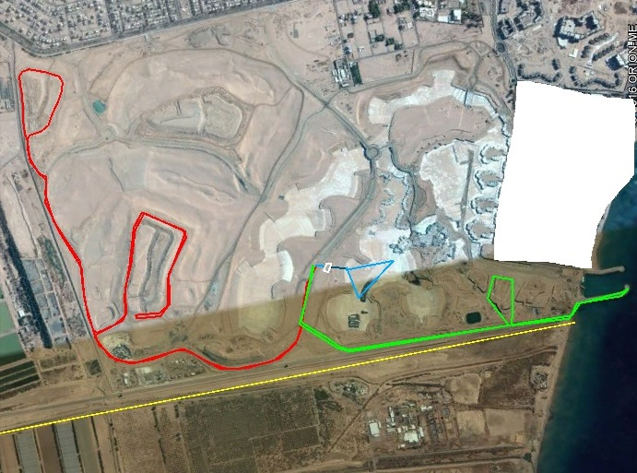
Blue line: Swimming 1 lap. Red line: Cycling 2 laps. Green line: Running 2 laps

8. RACES START TIMES

Race | Start time | Finish time
Race check in | 06:00am | 08:00am
Elite Triathlon | 09:00am | 10:15am
Age Group Triathlon & team Triathlon | 09:15am | 12:00am
Elite Duathlon | 09:45am | 11:00am
Age Group Duathlon | 09:45am | 12:30pm
Awards ceremony | 14:00pm

9. RULES
The Championship will be held under ASTC / ITU Rules and Regulations.

10. Judges & Officials
Judges & Official will be approved by ASTC.

6. PRIZES
Finishing a Triathlon or Duathlon is an achievement in itself, and as a recognition of the athletes hard work Jordan Triathlon Association in cooperation with Ayla Oasis will provide a total of USD 10000 as prize money for winners in the elite races also a number of sponsored prizes will be provided to the Age group athletes.

Elite Triathlon Elite Duathlon
Place | Men | Women
1st Place | US $ 1250 | US $ 1250
2nd Place | US $ 750 | US $ 750
3rd Place | US $ 500 | US $ 500
Place | Men | Women
1st Place | US $ 1250 | US $ 1250
2nd Place | US $ 750 | US $ 750
3rd Place | US $ 500 | US $ 500

11. TEAM LEADERS / MANAGERS and TECHNICAL OFFICIALS MEETINGS
The meetings will be held on the day before the Competition:

Team Leader & Managers Meeting | 17/Nov | 16:00 P.M

12. Ability Requirement:
The expected finish times are between 1 hour for an Elite athlete and 1 1/2 to 2 hours for Age Group athletes. All competitors must sign a waiver to compete. The swim is in a huge man made pool, with life guards present at all times. The cycle section is on closed roads inside the resort. The cycling route will be two laps, and the elevation is mostly flat. The running is 2 laps on a smooth tarmac taking athletes to the shores of the red sea and back to the finish line. Competitors in the triathlon must be competent swimmers.

13. Cycling:
The route is on smooth fully closed private road, so hopefully there should be no issues with punctures. However cyclists will face a number of speed bumps on the route. A wheel station along the route will be provided for athletes who wish to put their spare wheels, if athletes do get a puncture they should reach the station to change their wheel.

14. Health and Safety:
We will do our utmost to keep you safe. There will be an ambulance and first aid professionals present at the start area of the course. There will be lifeguards overseeing the water safety, and the run and cycle legs will be lined with marshals to keep an eye on everyone.

16. ACCREDITATION & Numbers
Accreditation Cards will be provided to each athletes, coaches, officials on the 16th & 17th November at the Accreditation center.
Participants Numbers will be provided to each participating athlete on the 17th November at the Accreditation center.

17. TRANSPORTATION

Airport Information: King Hussein International Airport - Aqaba

The Organizing Committee will welcome all members of the participating National Federations at the King Hussein International Airport -Aqaba.

Airport Transportation Services:

- From Airport to Hotel - USD 25 per person
- From Hotel to Airport - USD 25 per person

The Organizing Committee will not provide local transportation from / to Airport &from/to Hotel and competition venues for Teams /Athletes which accommodate in hotels not thorough the Organizing Committee.

To be able to arrange Airport Transportation, the Organizing Committee must receive Travel Information Form and Hotel Reservation form by 28 September 2016.

18. ACCOMMODATION

The Organizing Committee will organize accommodation to all participating Teams/Athletes. The official hotels for all the participating athletes and officials will be as follows:

18.1 - Double Tree Hilton (5*) - Aqaba

Room rates Bed & Breakfast are:
Single:125 USD (BB) per night/per person
Double:80 USD(BB) per night/per person

Rates per Meal per person ( Lunch or Dinner ) - USD 40 each

18.2 - MOVENPICK Aqaba (5*+) - Aqaba

Room rates Bed & Breakfast are:
Single:140 USD (BB) per night/per person
Double:90 USD(BB) per night/per person

Rates per Meal per person ( Lunch or Dinner ) - USD 40 each

18.3 - Ababa Gulf ( 4*) - Aqaba

Room rates Bed & Breakfast are:
Single:110 USD (BB) per night/per person
Double:70 USD (BB) per night/per person

Rates per Meal per person ( Lunch or Dinner ) - USD 20 each

To avoid cancellation charges, the Accommodation section must be notified of any amendments or cancellation latest by14 October 2016.

19. Entry VISA

For all participants & officials that require an entry visa prior to departing to Jordan, should contact the Jordanian Embassy or Jordanian Consulate in their country in order to obtain entry visa.

The Organizing Committee, can provide an invitation letter, if requested, provided that copies of a valid passport for all athletes & officials are sent with the request.

* For information about which countries and regions need to acquire VISA to enter Jordan and what kind of documents are necessary, please visit the website of the Ministry of Foreign Affairs of Jordan at http://www.jordan.gov.jo
/
Last Date to accept invitation letter request : no later than 23 September 2016

