Athlete Application Form
2024 Bishkek Asia Triathlon – World Triathlon Para- Development Camp

Bishkek, Kyrgyzstan – 24-27 Oct 2024

Generic Information
National Federation
NF Contact
e-mail

Name / details of proposed athlete
First name
(as worded on passport)
Family name
(as worded on passport)
World Triathlon Registration Number (if applicable)
E-mail address (individual)
Date of Birth
(dd/mm/yyyy)
Gender | Male | Female
Please indicate if you have any special nutritional requirements!

Performance (the best time of Swim and Run within 3 months)
Swim | 100m | 400m
 | (mm:ss) | (mm:ss)
Run | 1,500m | 3,000m
 | (mm:ss) | (mm:ss)

Athlete - Background in sport*
How many years have you participated in other sports before starting triathlon?
Sport |  | Years in sport
Sport |  | Years in sport
Sport |  | Years in sport
How many years have you participated in Triathlon?
Current training frequency & volume | Current km’s per week |  | Current Sessions per week
Swim
Bike
Run

Athlete - Primary sporting achievement*
Event | Result | Year | Place

* NFs can supplement this information with the athlete’s sporting CV if available.

Athlete - Participation in World Triathlon and/or Confederation Development Projects
Have you participated in any World Triathlon or Confederation Development Projects (scholarship, camp, ASICS World Triathlon Team)? |  | No
If, yes, please specify!
Project | Where? | When?

Optional Attachments
Optional Attachments will facilitate approval procedure if submitted | Enclosed
1. Long Term Strategic Plan of the National Federation | Yes | No
1. Detailed sporting curriculum of athlete | Yes | No
1. Copy of athlete’s passport | Yes | No

I, the undersigned, Representative of the National Federation and the Candidate, certify, that the information provided above is accurate, true and correct.

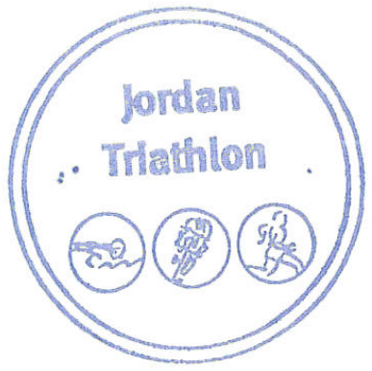
NF Representative Name, Function and Signature | Stamp | Signature of the Candidate or Parent for U18 candidates

This application must be sent to: [name] (e-mail) latest by the application deadline published on https://www.triathlon.org/development/calendar.

